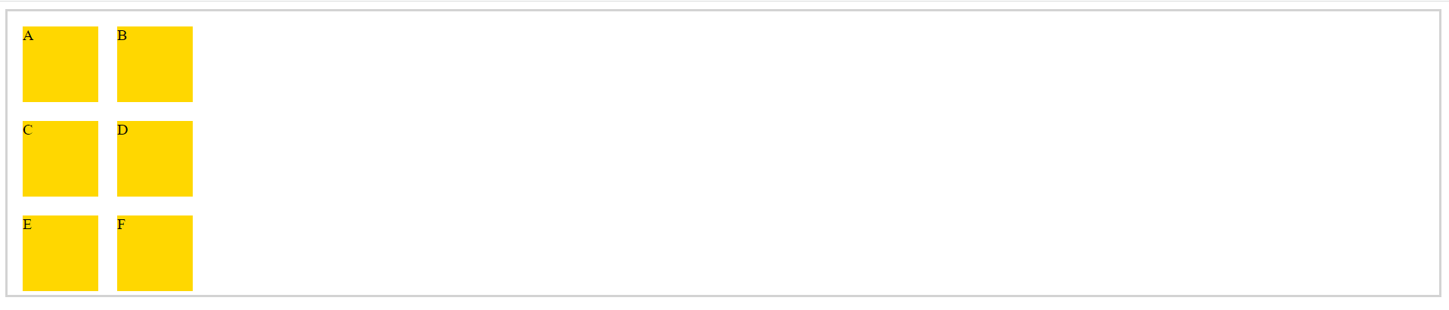

<div class="container">

<div class="box">A</div>

<div class="box">B</div>

<div class="box">C</div>

<div class="box">D</div>

<div class="box">E</div>

<div class="box">F</div>

</div>

.container

{

    display: grid;

    grid-template-rows: repeat(3, 100px);

    grid-template-columns: repeat(2, 100px);

    border: 3px solid lightgrey;

}

.box

{

    width: 5rem;

    height: 5rem;

    background: gold;

    margin: 1rem;

}

|  |  |
| --- | --- |
| Class | Properties |
| grid-cols-1 | grid-template-columns: repeat(1, minmax(0, 1fr)); |
| grid-cols-2 | grid-template-columns: repeat(2, minmax(0, 1fr)); |
| grid-cols-3 | grid-template-columns: repeat(3, minmax(0, 1fr)); |
| grid-cols-4 | grid-template-columns: repeat(4, minmax(0, 1fr)); |
| grid-cols-5 | grid-template-columns: repeat(5, minmax(0, 1fr)); |
| grid-cols-6 | grid-template-columns: repeat(6, minmax(0, 1fr)); |
| grid-cols-7 | grid-template-columns: repeat(7, minmax(0, 1fr)); |
| grid-cols-8 | grid-template-columns: repeat(8, minmax(0, 1fr)); |
| grid-cols-9 | grid-template-columns: repeat(9, minmax(0, 1fr)); |
| grid-cols-10 | grid-template-columns: repeat(10, minmax(0, 1fr)); |
| grid-cols-11 | grid-template-columns: repeat(11, minmax(0, 1fr)); |
| grid-cols-12 | grid-template-columns: repeat(12, minmax(0, 1fr)); |
| grid-cols-none | grid-template-columns: none; |

|  |  |
| --- | --- |
| Class | Properties |
| grid-rows-1 | grid-template-rows: repeat(1, minmax(0, 1fr)); |
| grid-rows-2 | grid-template-rows: repeat(2, minmax(0, 1fr)); |
| grid-rows-3 | grid-template-rows: repeat(3, minmax(0, 1fr)); |
| grid-rows-4 | grid-template-rows: repeat(4, minmax(0, 1fr)); |
| grid-rows-5 | grid-template-rows: repeat(5, minmax(0, 1fr)); |
| grid-rows-6 | grid-template-rows: repeat(6, minmax(0, 1fr)); |
| grid-rows-none | grid-template-rows: none; |